Introduction
In modern electronics, it is important to be able to separate a signal into different frequency regions. In analog electronics, four classes of filters exist to process an input signal: low-pass, high-pass, band-pass, and band-stop. Further, many different types of filters exist under each major class. For example, elliptical, Butterworth, and Chebyshev filters all exist under the low-pass class of filter. Each filter is classified by a transfer function that defines the gain for the circuit for all input frequencies. While each of these filters may be used under different circumstances, the elliptical filter is a filter with widespread application, due to its sharp frequency cutoff and equiband ripples. Also, it exemplifies several characteristics seen in other types of filters, which makes it excellent for student design and analysis.

Filter Characteristics
Several notable characteristics define the elliptical filter. A brief visual interpretation of all of these characteristics is shown in Figure 1. Like the Chebyshev filter, the elliptical filter contains a ripple, defined by the variance in output voltage from either the maximum or minimum output. However, unique to the elliptical filter is an equal dB ripple in both the pass-band, the frequency region that is passed with minimal attenuation, and the stop-band, the frequency region that is severely attenuated. In a filter with a ripple on the stop-band, the voltage rise after cutoff may detrimental effects on connected circuitry if incorrectly designed. Because of this, the elliptic filter is also classified by its A_{min} value. This value, in decibels, indicates the guaranteed minimum drop from DC response such that the output may never rise past this threshold after cutoff. Finally, the filter is characterized by the w_{s}/w_{c} value. This value defines the roll-off, or how fast the filter drops from the cutoff frequency to the stop-band.
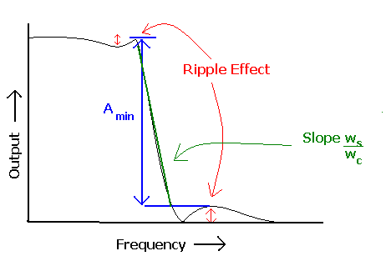
Figure 1. The defining characteristics of an elliptic filter.

Elliptic Filter Advantages
The elliptical filter has an extremely sharp cutoff frequency, which makes it ideally suited for filter design cases where there must be severe attenuation in frequencies just entering the stop-band of the filter. Further, because the rippling effect is distributed across both the pass- and stop-bands in the elliptic filter, it makes it an excellent candidate for a low pass filter where the amount of error needs to be minimized on both sides of the cutoff frequency. The Chebyshev filter, with a slower roll-off and an imbalanced ripple, does not offer either of these advantages. Therefore, in cases where there are signals that are very close and must be cut off at exactly or very close to one particular frequency, the elliptic filter is recommended.
Elliptic Filter Computer Design and Testing
Here, an example elliptic filter of the third order will be designed in the Orcad PSpice program. After the electronic design and test, a real-world device will be tested using LF351 operational amplifiers. First, the defining characteristics of the filter, w_{s}/w_{c} and the dB ripple are chosen to be 1.5 and 0.5dB respectively. Next, the notch frequency, f_{n}, is chosen to be 7.5kHz. The Thompson Phase Approximation may be used to look up the constant values for this definition. The values for this problem may be seen in Table 1. The values for the third order filter are then placed into Equation 1. It is also important to note the cut-off frequency, f_{c} = f_{n} / c₁ and f_{s} = w_{s}/w_{c} * f_{c}. Once this is done, a capacitor value of 10nF is chosen so the values for all resistors may be calculated as per Equations 2. For this particular circuit, R=R₁=3.3kΩ, R₄=7.5kΩ, R₂=8.2kΩ, R₃=18kΩ, f_{c}=4477Hz, and f_{s}=6715Hz. As seen in Figure 2, these resistances and capacitances are placed in the PSpice circuit diagram. If the designer so desired, the circuit could be modified to be an elliptic filter of either higher or lower order by looking up the new constants from the table, placing them in the frequency response formula, and recalculating all of the resistances. Further, if the resistances are not within allowable values, they may be recalculated by changing the capacitance value, C, to some other arbitrary value.
Now, the circuit simulation may be run. This simulation should be set up as an AC sweep from 1Hz to 1MHz, so that the frequency response may be plotted. This should produce a plot of frequency response. The output from this should look like the graph shown in Figure 3. With this graph, the characteristics may be ensured as correct. First, the ripple may be tested to ensure that it is equal on either side of the cutoff frequency. Using the markers in PSpice, it may be seen that the pass-band ripple goes down to 0.936V, a drop of 1-0.936 = 0.064V. Looking at the stop-band side, the ripple rises to 0.076V. The difference in these values is negligible, and caused by rounding errors in resistance values. Next, the value of A_{min} will be checked. The output starts at 1V, and after the cutoff, rises to a maximum of 0.076V. Using Equation 3, we may calculate the value of each of these outputs in decibels. It is readily seen that the 1V output corresponds to 0dB drop while the 0.076V output corresponds to a drop of 22.38dB. This exceeds the A_{min} value in the table by .48dB, ensuring the designer of its validity.
Table 1. Elliptic Alignments for w_{s}/w_{c} = 1.5
Order | A_{min} | i | a_{i} | b_{i} | c_{i}
2 | 8.3 | 1 | 1.2662 | 1.2275 | 1.9817
3 | 21.9 | 1 | 1.0720 | 2.3672 | 1.6751
3 | 21.9 | 2 | 0.76695
4 | 36.3 | 1 | 1.0298 | 4.0390 | 1.5923
4 | 36.3 | 2 | 0.68690 | 0.74662 | 3.4784
5 | 50.6 | 1 | 1.0158 | 6.2145 | 1.5574
5 | 50.6 | 2 | .75895 | 1.3310 | 2.3319
5 | 50.6 | 3 | .42597

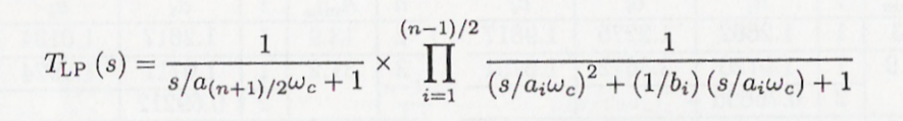 Eq. 1 ^{[1]}
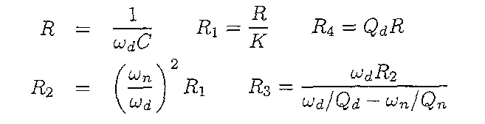 Eq. 2^{[1]}
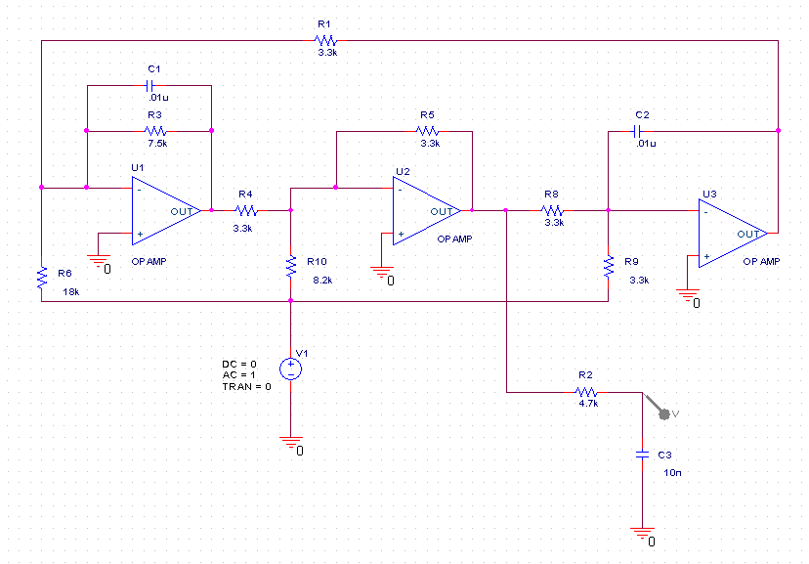Figure 2. Third order elliptic filter schematic.
dB = 20 log (V_{o}) Eq 3.
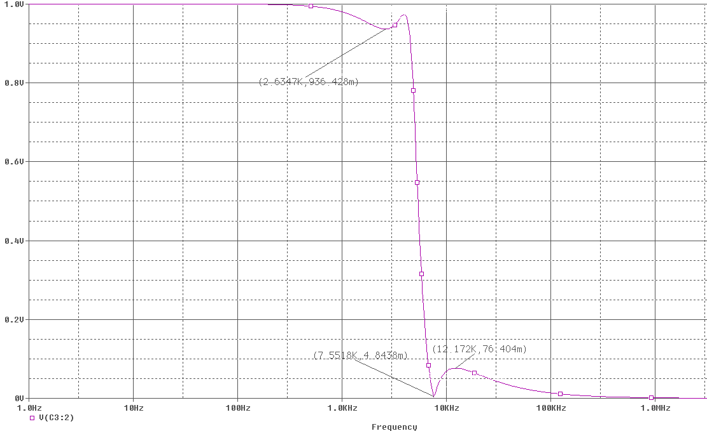Figure 3. Frequency response of third order elliptic filter.
The second test that may be simulated is to feed a sum of three sinusoids into the input. These sinusoids should be carefully chosen such that one lies well into the pass-band, one lies on the notch frequency, and one lies at the stop band. Using f = f_{n}/2, f_{n}, and 2*f_{n} fits this description. The FFT function built into PSpice will display spikes at each frequency where there is a component of frequency response. As seen in Figure 4 (the input waveform is in blue and the output waveform is in purple), the filter completely nullifies the signal at f= f_{n} and significantly attenuates the signal at f=2*f_{n}. It allows the signal at f= f_{n}/2 to pass with very little effect on the output.
Real Device Testing
Real world devices tend to be significantly different than the theoretical devices modeled by PSpice. Therefore, it is important to check all calculations with a real device. The circuit shown in Figure 2 may be built using LF351 operational amplifiers and 5% resistors to test the robustness of the design. After the circuit is built, the output may be hooked up to the DMM while the input is hooked up to the function generator. One of the VEE programs may be run to produce a frequency response output, as measured by the DMM. The VEE program outputs to logarithmic scales on both the X- and Y-axis. It may be easier to view the output in its linear form. To do this, export the X (frequency) and Y (dB) to a file with a “write to file” block in the VEE program. You can open this file in Microsoft Office’s Excel and plot the points. Using Equation 4 on the output in dB will convert the output to voltages. The plot of this may be viewed as Figure 5. Now the parameters of the real device may be calculated. First, it is noted that the output does not go above 0.984V. Next, it is noted that the ripple in the pass band drops to a minimum of 0.919V, or a drop of 0.984-0.919=0.065V. The ripple in the stop-band does not rise above 0.0755V. One can use inspection to notice that these ripples are approximately equal. Next, A_{min} will be tested for accuracy. Again, using Equation 3, there is a drop from -0.14dB to a maximum of –22.44dB. This yields an A_{min} of 22.3, which is, again, higher than the value of 21.9, as listed in Table 1. Filling in the collected data to Table 2, it is easily seen that the predicted data is extremely accurate for a real-world device. Even though non-ideal operational amplifiers and 5% resistors are used, all measurements are within 2% of the expected values.
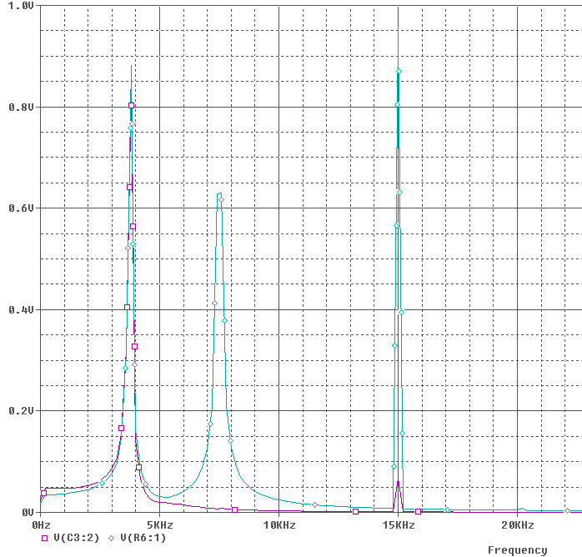
Figure 4. Frequency response with three-sinusoid input.
C_{n}=10^(B_{n}/20) Eq. 4
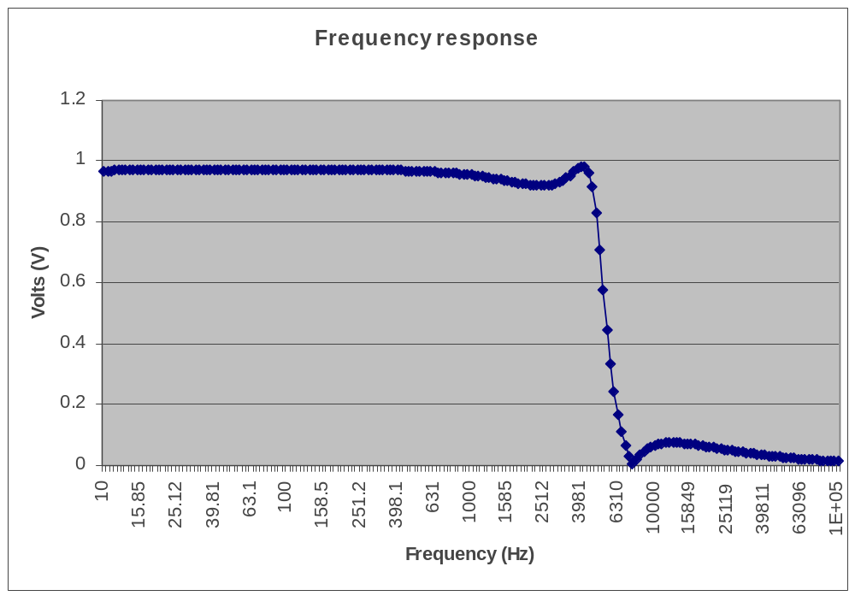
Figure 5. Frequency response of real third order elliptic filter
Table 2. Error calculations
 | A_{min} | f_{s} | f_{c} | f_{n} | dB ripple
Theoretical | 21.9 | 6715Hz | 4477Hz | 7500Hz | 0.5dB
Tested | 22.3 | 6800Hz | 4400Hz | 7585Hz | 0.5008dB
% Error | 1.79% | 1.24% | 1.73% | 1.13% | 0.16%

The next test is to use the sum of three sinusoids as an input waveform to the filter. Using the FFT math function of the oscilloscope, the three frequency bands may be seen. As seen in the computer simulation and now in Figure 6, the input waveform is the composition is the composition of three peaks representing each sinusoid. These waveforms are created by saving a vector of outputs to a file and importing this vector to the arbitrary waveform generator. In order to see how the filter acts on real inputs, the output is also run through the oscilloscope’s FFT function. As seen in Figure 7, the filter does indeed severely attenuate the highest signal and completely nullifies any detectable reference of f=f_{n}.
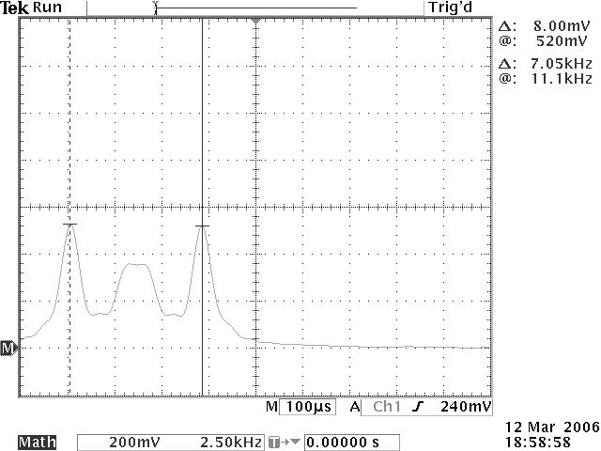
Figure 6. Sum of three sinusoids input to real filter.
Additional Applications
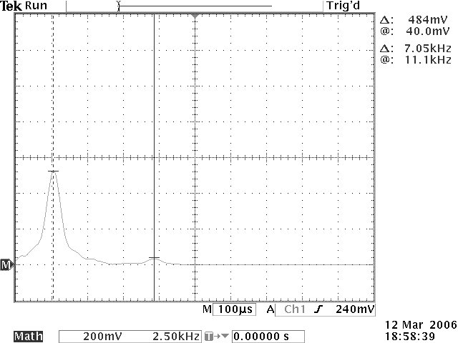
Figure 7. FFT output from filtered sum of sinusoids.
While it is important for electrical engineering students to understand the core concepts of analog filters, it is also important for them to understand where the filters are used. Due to their ubiquity, it would be difficult to list all applications. However, there are several common uses for an elliptical filter in engineering design. One is separating audio signals by type. A subwoofer typically handles low frequency signals, and thus it is important that it not try to process high frequency signals. In this case, a elliptical filter going into the input of the subwoofer would filter out these high frequency signals and leave the device with the sound it should output. Another common use would be in television signal processing. There is often high frequency noise in a video signal which must be filtered out. The sharp roll-off of the elliptical filter would be necessary to ensure that the television receives all of the signal that it should but nothing that would go over its maximum refresh rate, which could cause hardware problems.
Summary
The elliptical filter is an essential part of many modern electronics, and thus, an essential part of any undergraduate electrical engineering curriculum. As seen in this set of experiments, the elliptical filter is excellent for a low-pass filter with a sharp roll-off. It has an equal ripple in both the pass- and stop-bands, which minimizes the amount of error on either side of the cut-off frequency.

References
[1] Experiments in Modern Electronics. Brewer and Leach, Jr., 2003. Kendall/Hunt Publishing Company. Dubuque, Iowa.

